**12 - R710 Proxmox VM – Ubuntu Workstation with STATIC IP**

**Log in to Proxmox:**

1. In Firefox, go to : https://192.168.124.**201**:8006

User: root

Password : <whatever>

**Storage area for uploading ISO’s into**

1. Download the required Ubuntu Workstation 64 bit LTS to local PC end then click the “Upload” button to end up with something similar to:  
   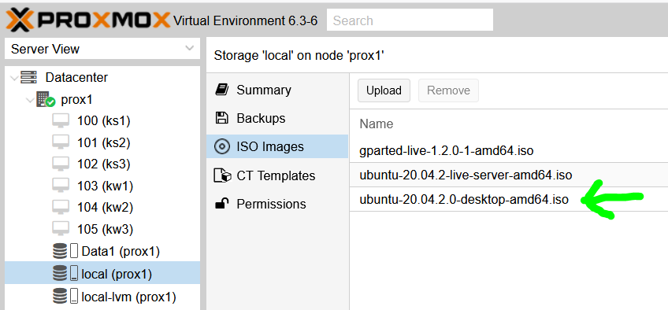

**VM – Full Virtual Machine ( Ubuntu 20.04 LTS )**

1. This example covers a single VM for development work, etc of apps to run in Kubernetes cluster.
2. With ‘prox1’ node selected, click “Create VM” and fill in Name, thus (ensure Advanced is ticked):

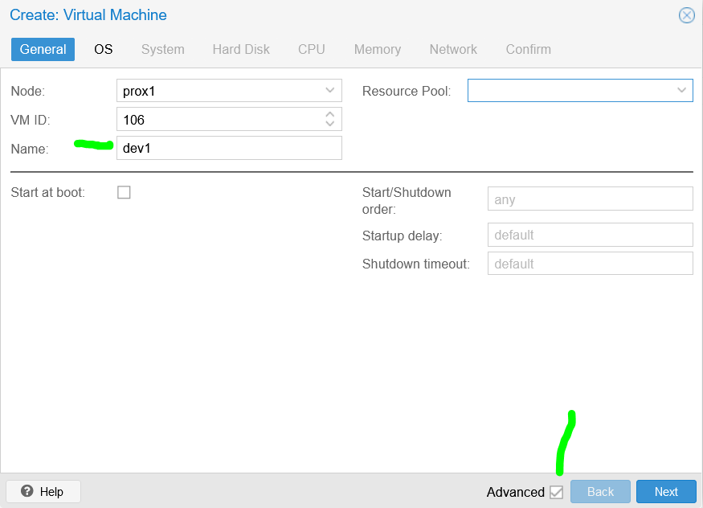

1. Select the ISO image to install from:  
   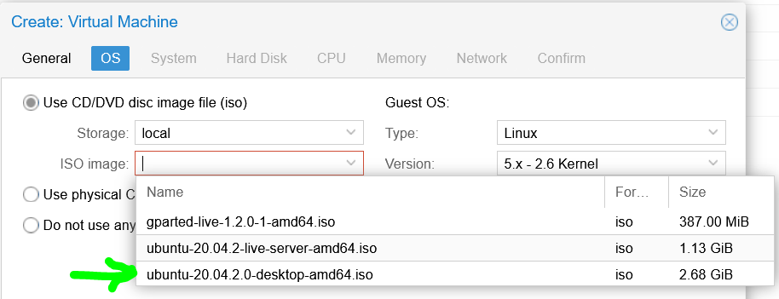
2. Leave System as is:  
   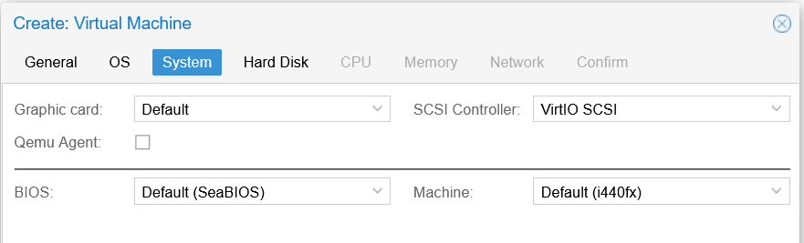
3. Hard Disk, adjust to 80GiB **AND** set storage to be **local-lvm AND** set the Bus/Device to **VirtIO** Block (for better Linux performance):  
   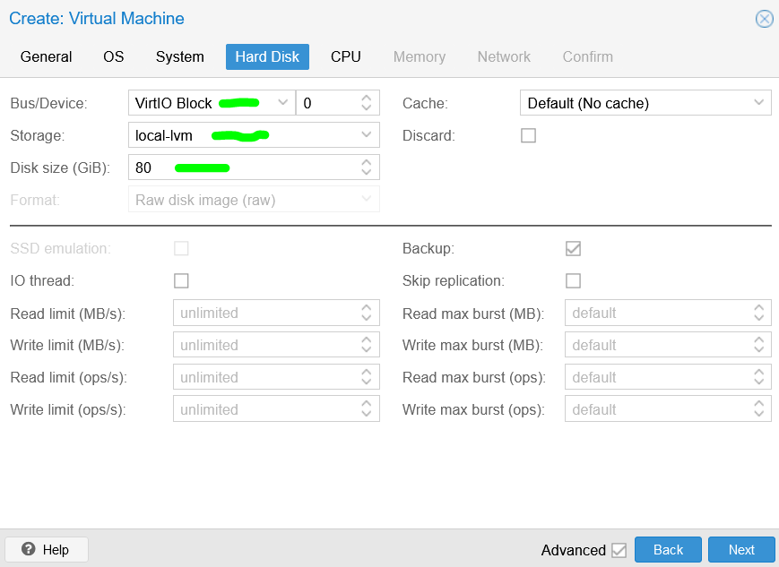
4. CPU, adjust as follows (host for virtualisation pass through):  
   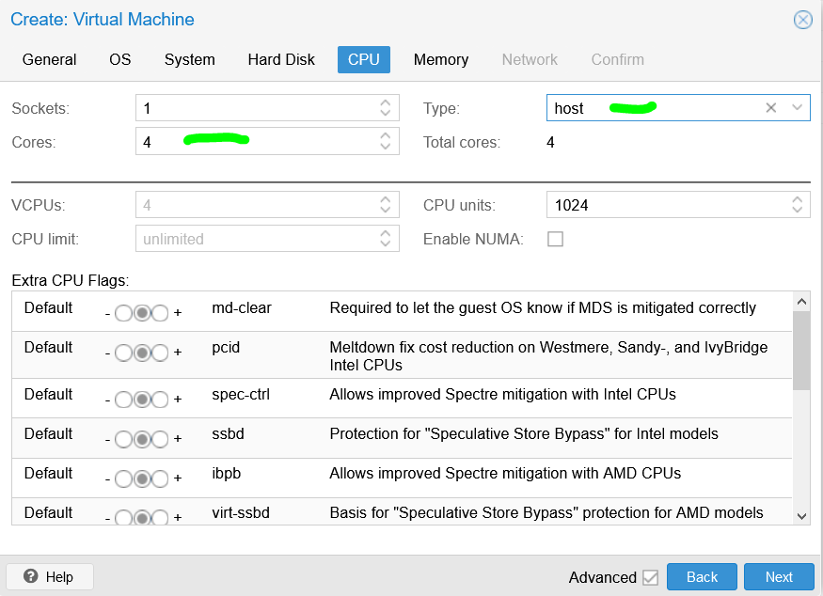
5. Memory, adjust as follows:  
   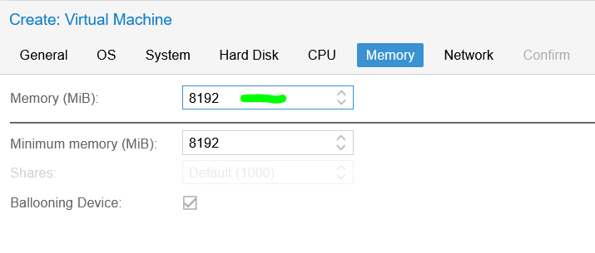
6. Leave Network as is:  
   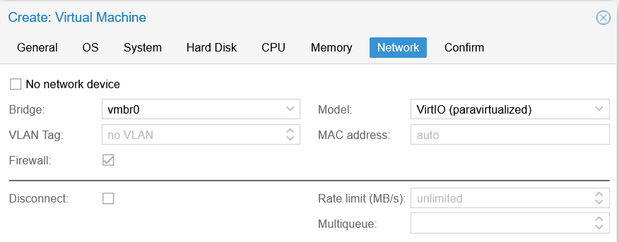
7. And on Confirm, click Finish, to get to this::  
   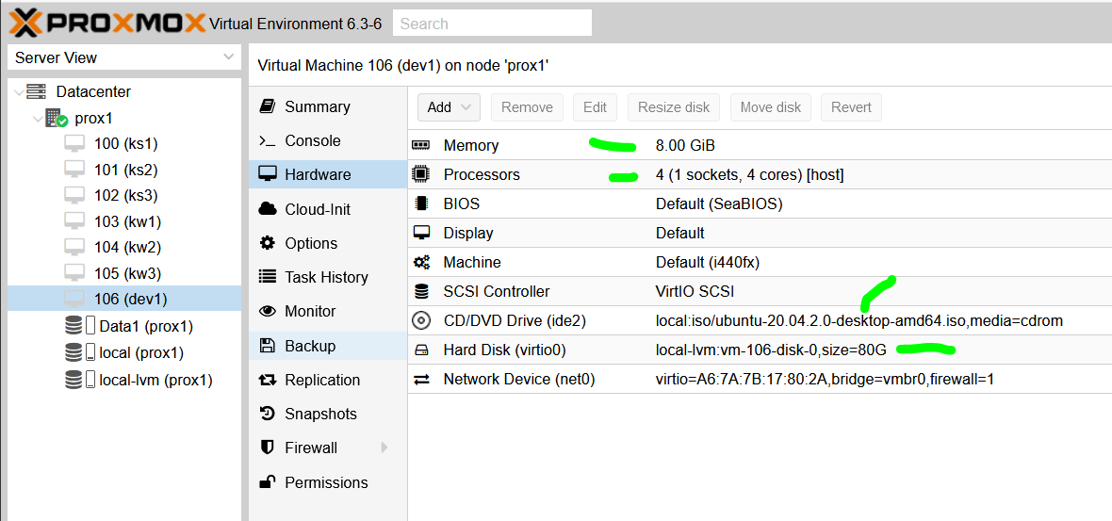
8. Select dev1, click on Console to get:  
   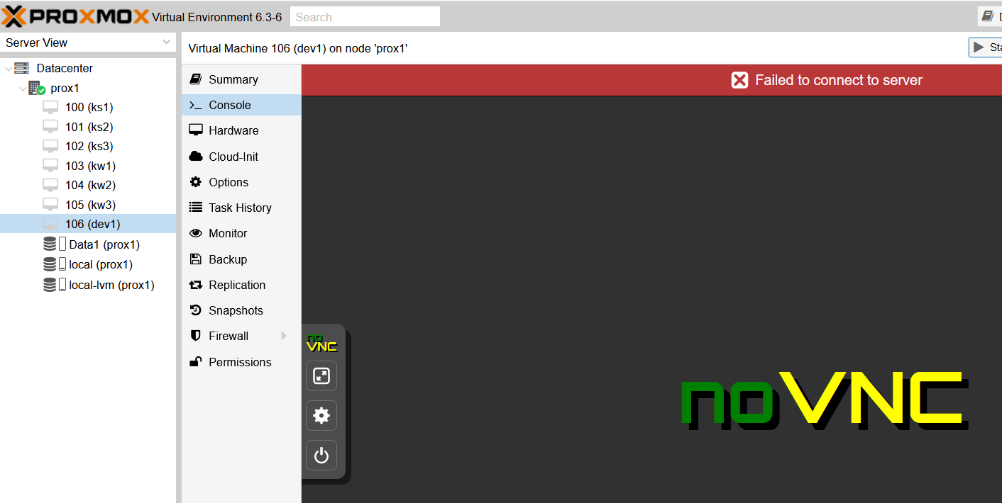
9. Click on Start, Ubuntu will start to install … and gets to the first screen:  
   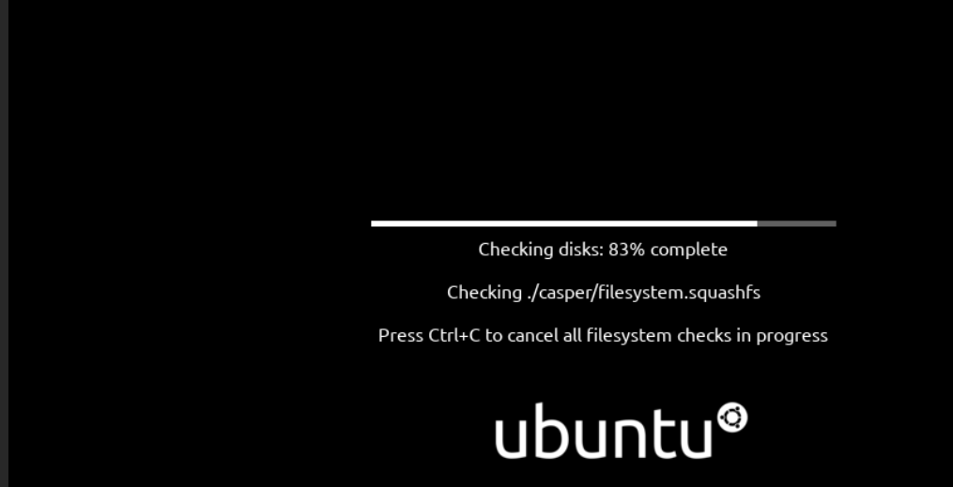
10. On this screen:  
    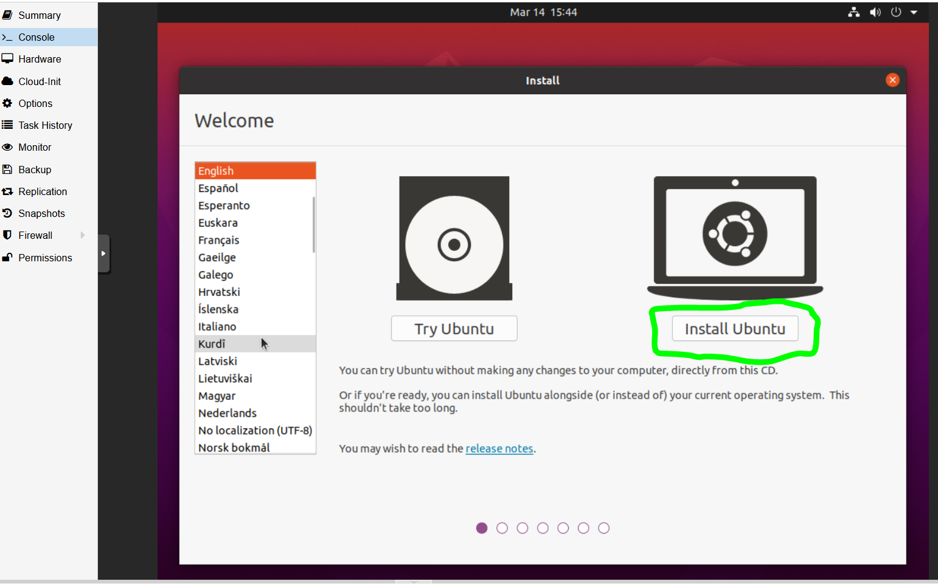  
    Click on “**Install Ubuntu**”
11. On this screen:  
    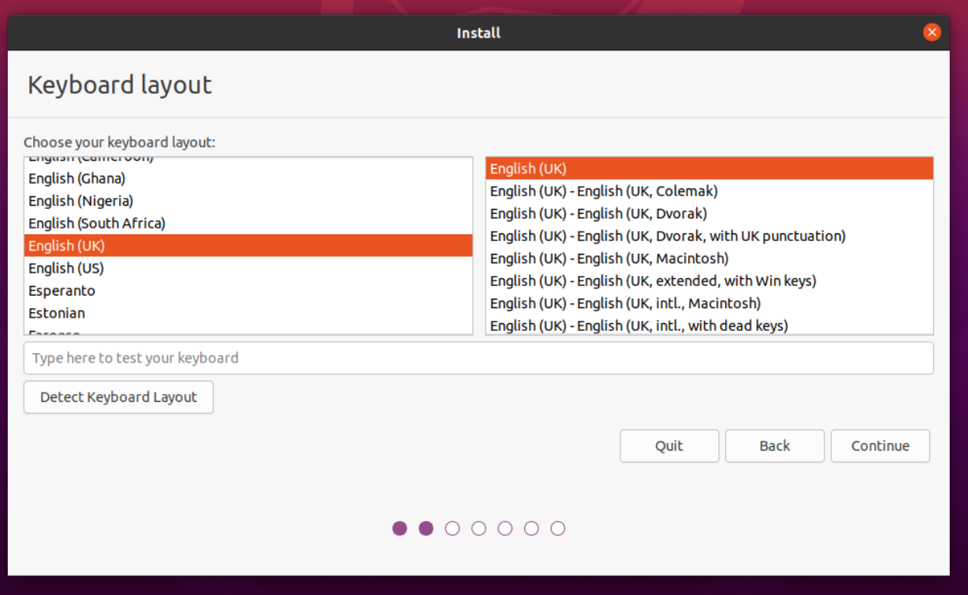  
    Click on “**English (UK)**” and then click on **Continue**
12. On this screen, leave settings as is:  
    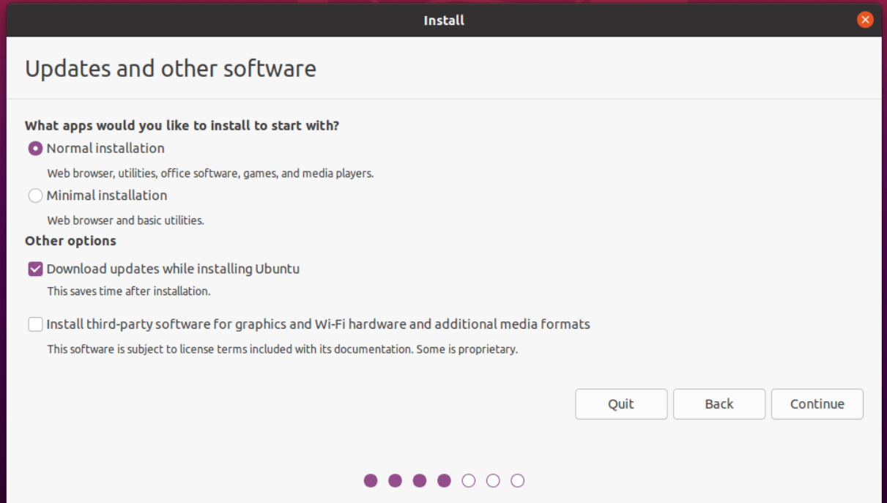  
    and click **Continue**
13. On this screen, leave settings as is:  
    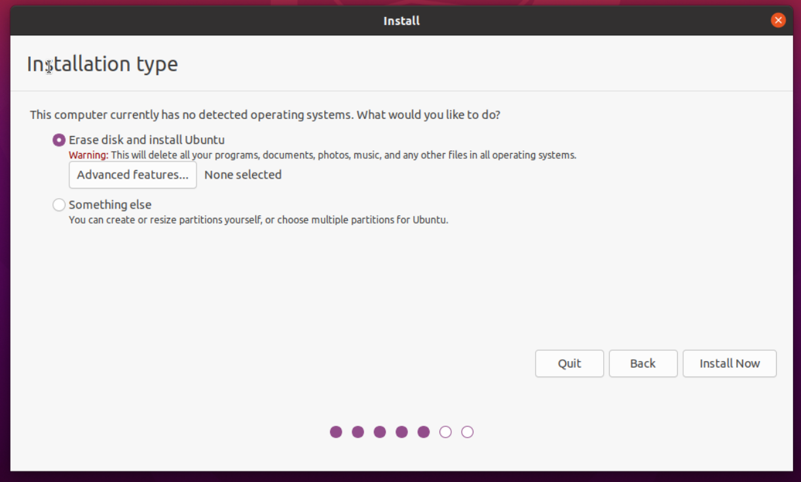  
    and click “**Install Now**”
14. On the popup window:  
    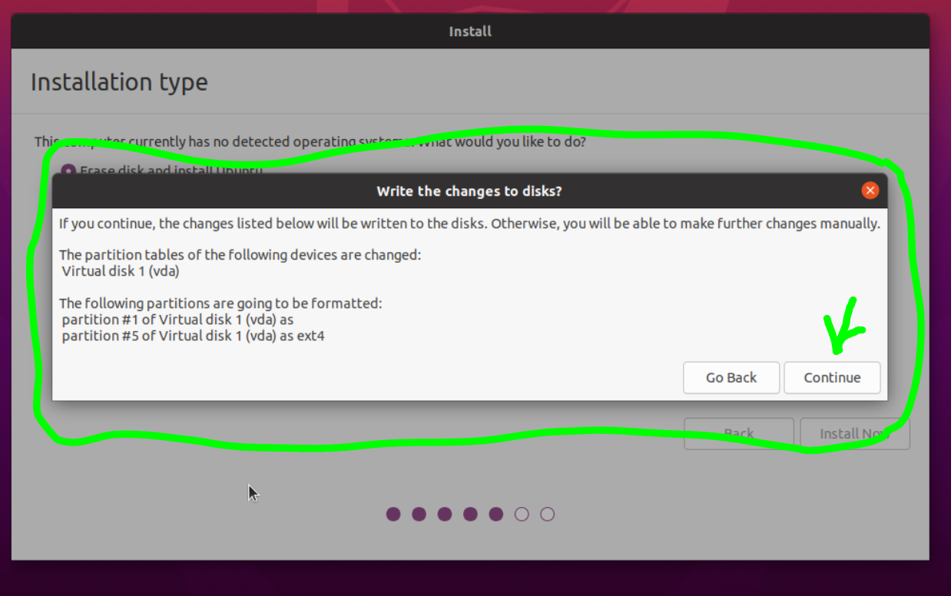  
    click **Continue**
15. On this screen, select **London**:  
    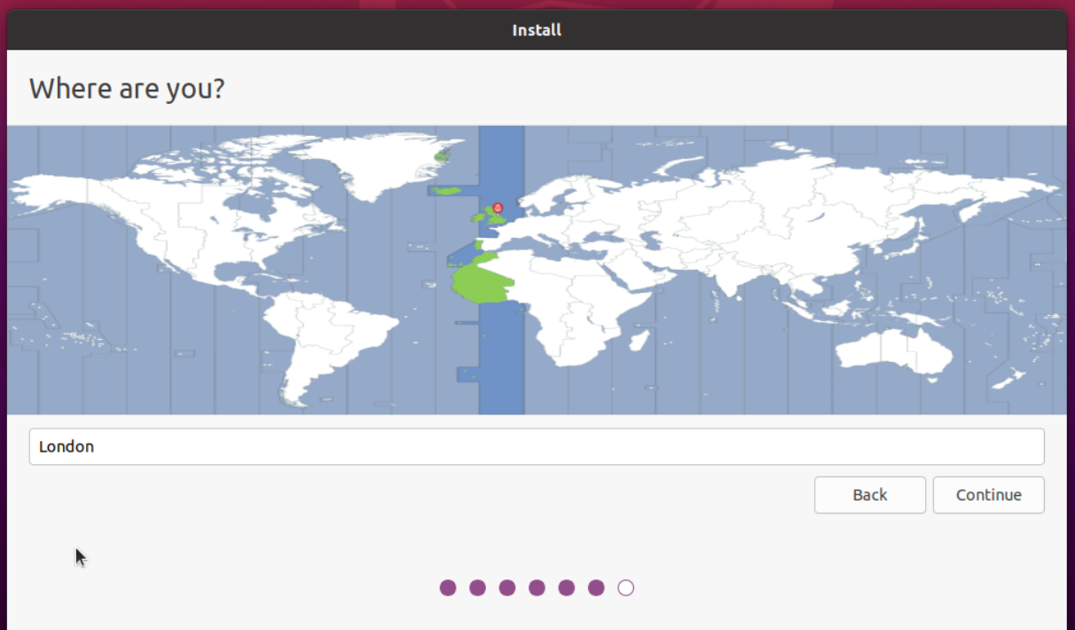  
    and click **Continue**
16. Fill in details on this screen (set computer name to: **dev1**):  
    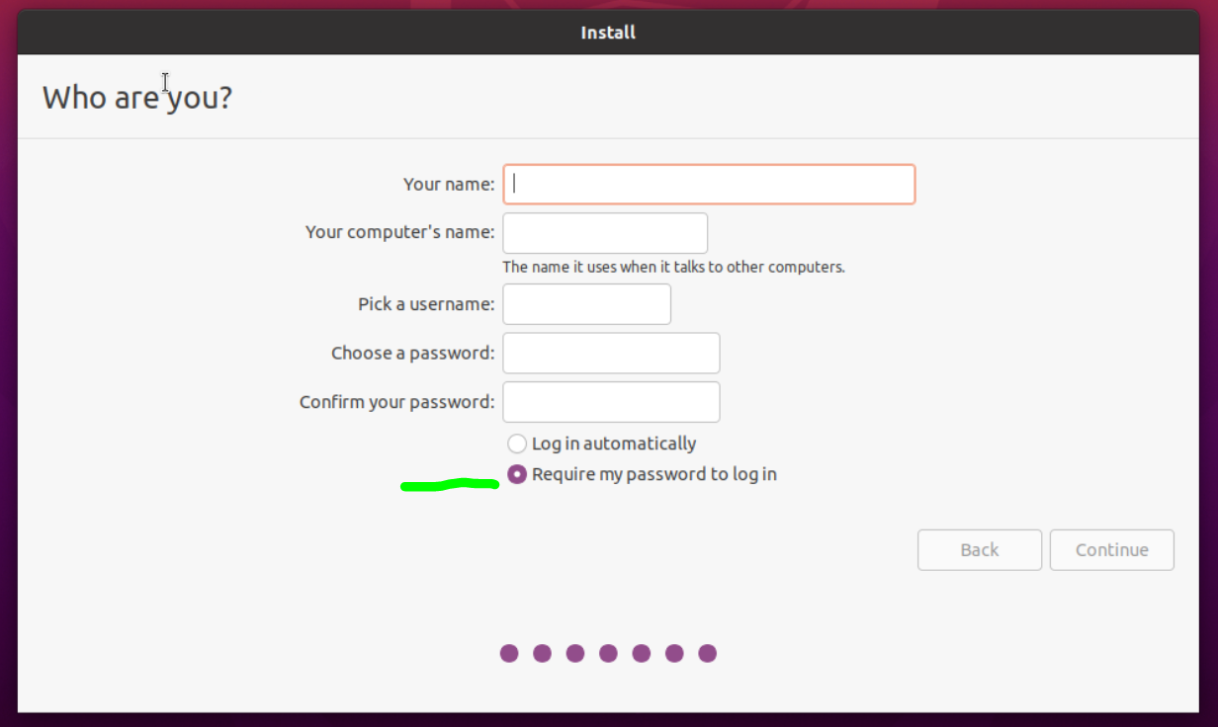  
    and make sure “Require password” is selected, and click **Continue**
17. The OS will now install, and eventually get to:  
    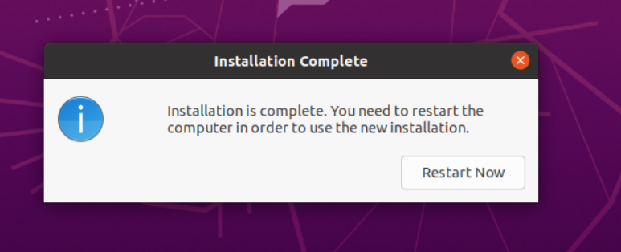  
    so, click “**Restart Now**”
18. You will be presented with:  
    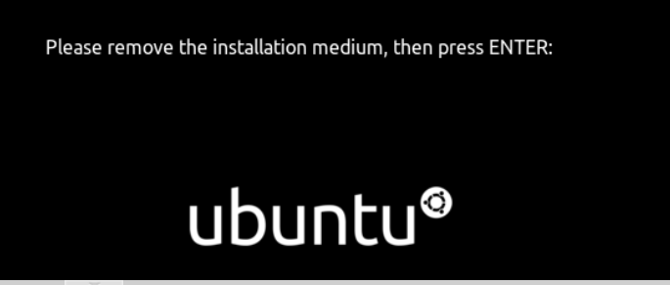  
    so, press **ENTER**
19. You will now see the logon screen:  
    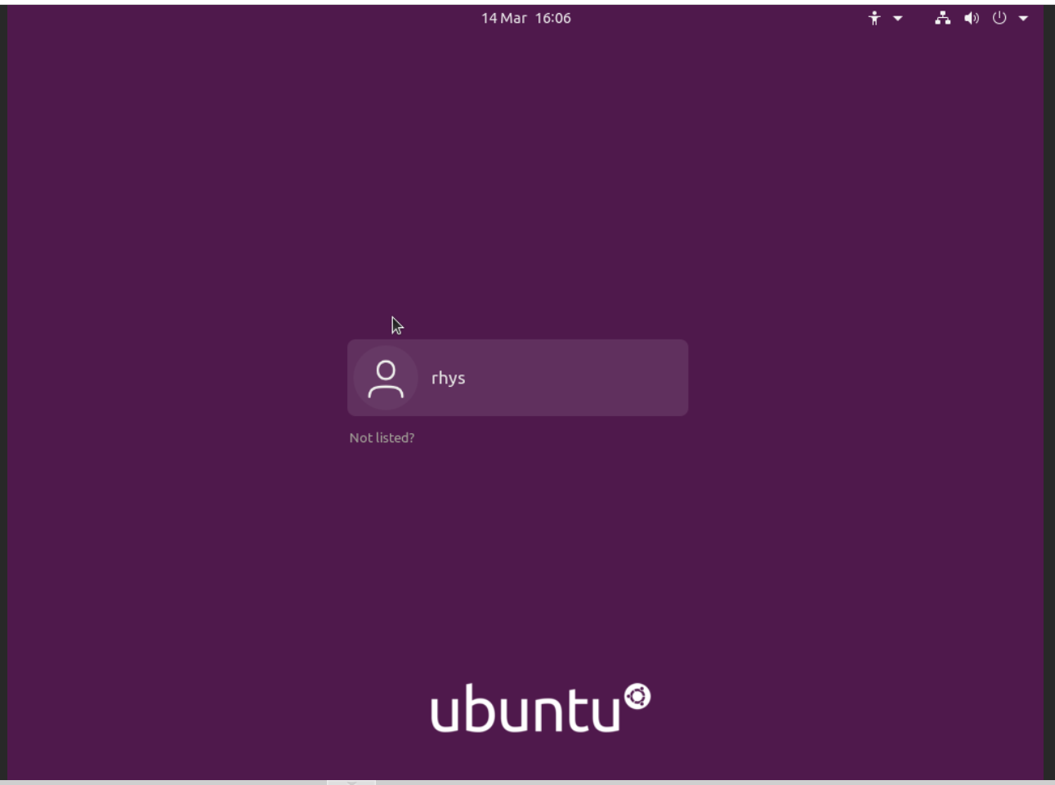  
    Click on the user name, and proceed …
20. On this screen:  
    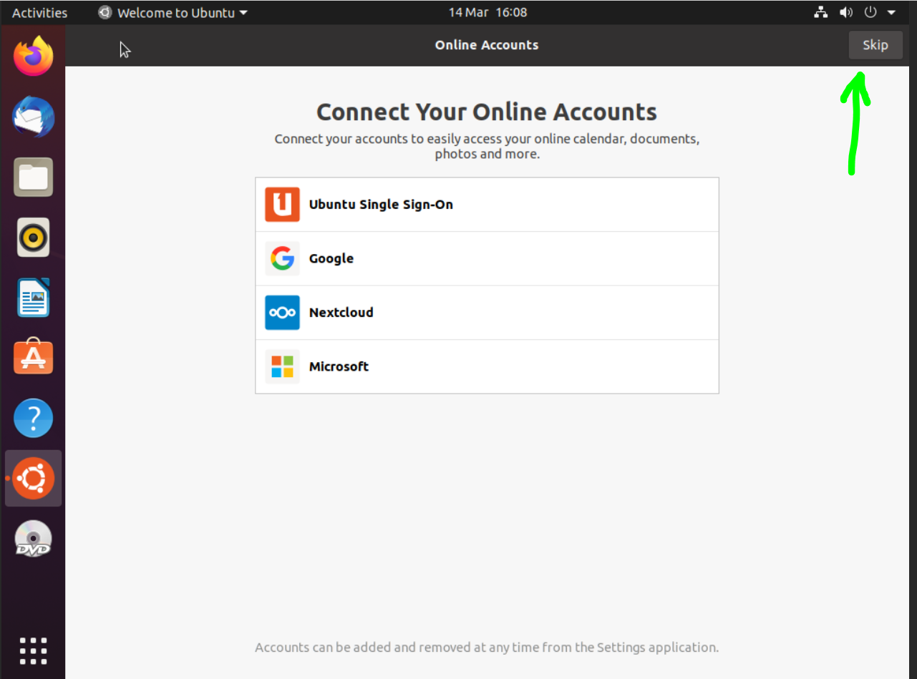  
    click on **Skip**
21. Next you are asked to setup live patch, so click on **Next** to skip this:  
    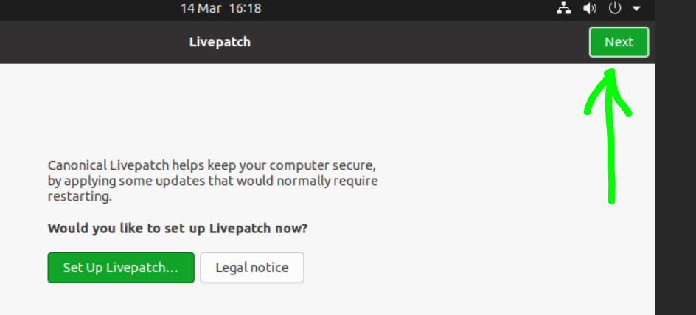
22. On the next screen, ensure the following is selected and click **Next**:  
    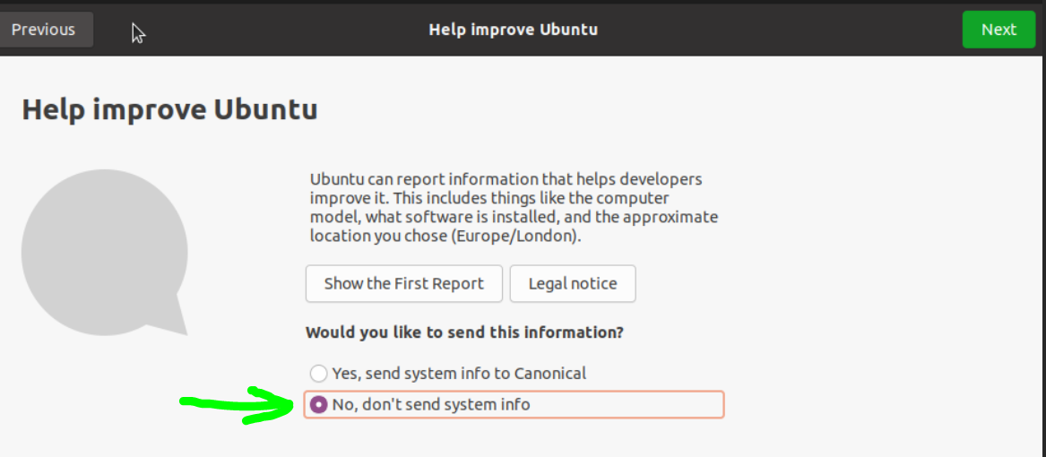
23. Leave **Location Services** un-selected and click **Next**:  
    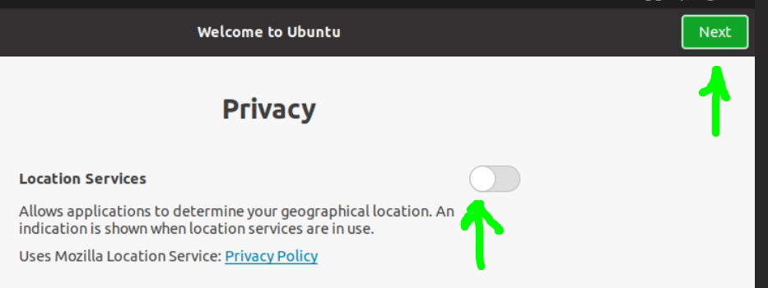
24. And on this click **Done**:  
    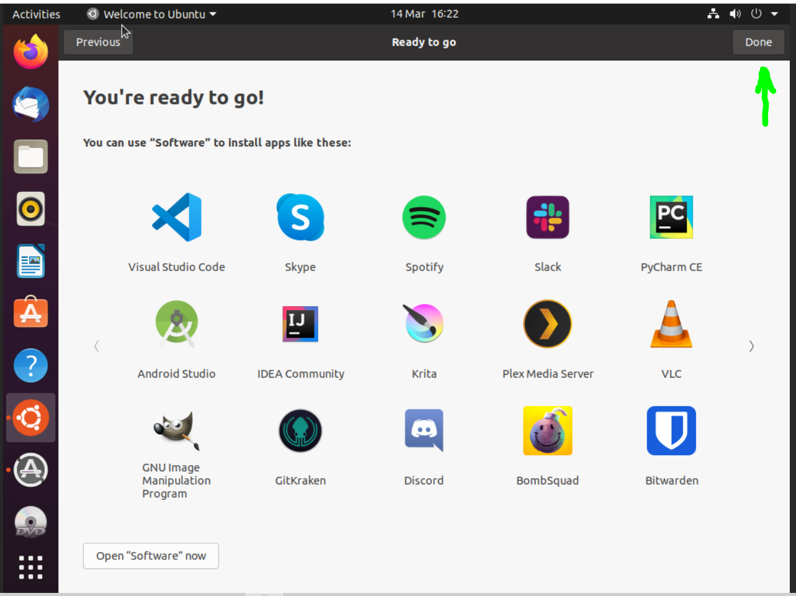
25. For the “**Software Updater**”, click on **Install Now**:  
    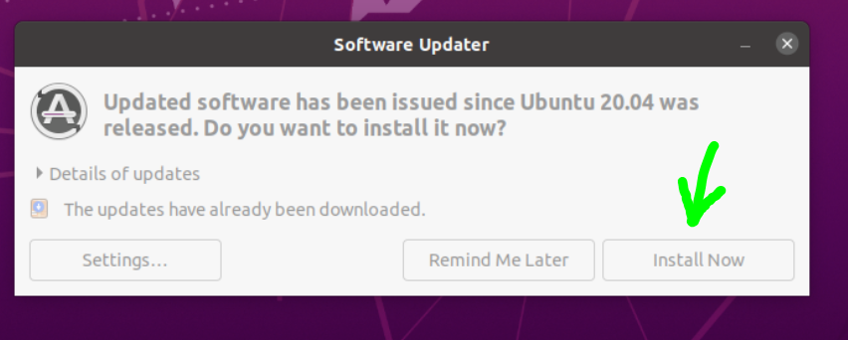
26. Once the software update is complete, carry on.
27. The VM stored in the “local-lvm” which is of type LVM-Thin (which does not pre-allocate all of the storage space – it is allocated as needed).
28. Do CTRL-ALT-T to open a terminal and as root do:  
    sudo usermod –aG sudo <user name>
29. Log out and back in again for above to take effect.
30. Follow the rest of the instructions below:

-=-=-

**Changing IP address on Ubuntu 20.04 LTS**

See this article:

<https://www.tecmint.com/set-static-ip-address-in-ubuntu/>

and work through it to setup the following settings:

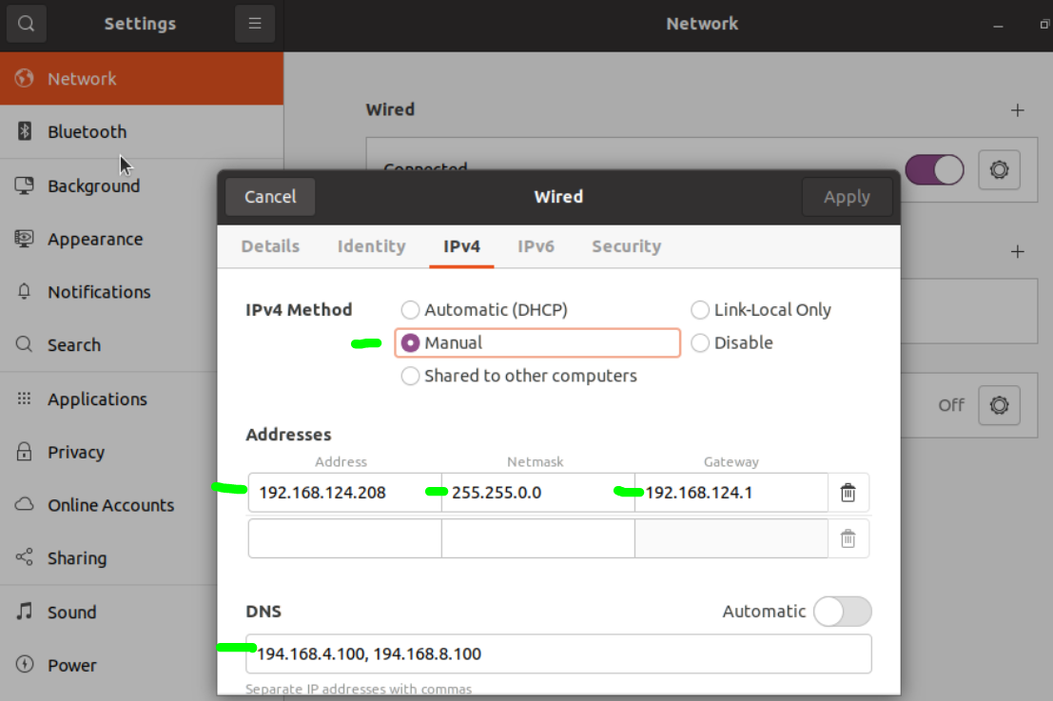

On the left of the screen, Eject the install DVD and then Power off the machine (top right drop down).

-=-=-

# Enabling SSH on Ubuntu:

**sudo apt update**

**sudo apt install openssh-server**

**sudo ufw allow ssh**

-=-=-

## Enabling Remote Desktop Access from Windows

**sudo apt install xrdp**

**sudo systemctl enable --now xrdp**

**sudo ufw allow from any to any port 3389 proto tcp**

-=-=-

## Enable GNOME Classic Mode

**sudo apt install gnome-shell-extensions**

logout, and from login screen, click the cog icon and select “GNOME Classic” session.

-=-=-

## Other commands to install

**sudo apt install net-tools**

**sudo apt install curl**

-=-=-

That completes the creation and initial setup of the Workstation VM.